PRACTICAL NO:03

Configure Routers with the ssh :

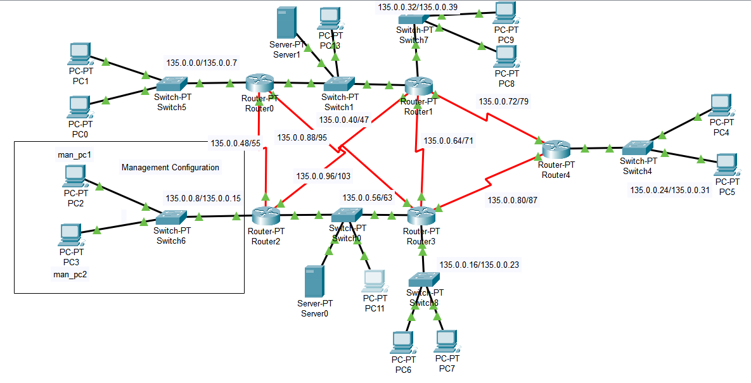

Configure ssh Routers -> Router1

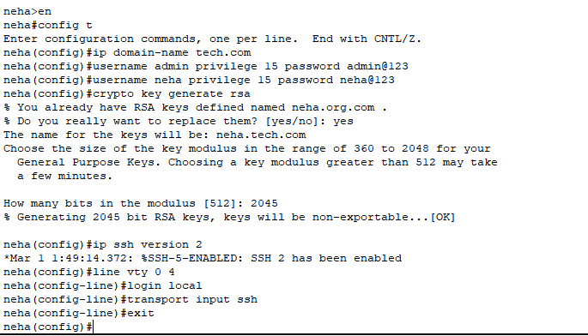

Router2:

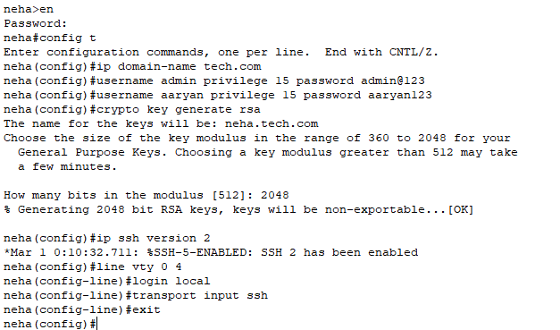

Router3:

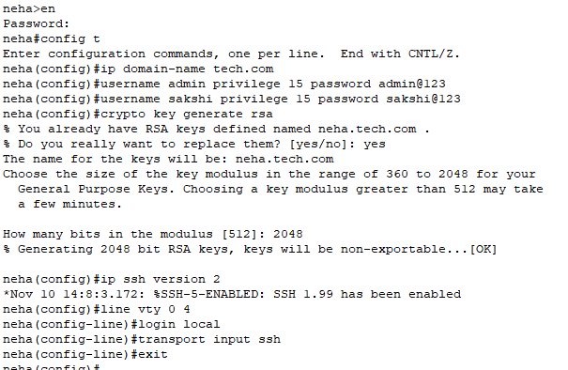

Router4:

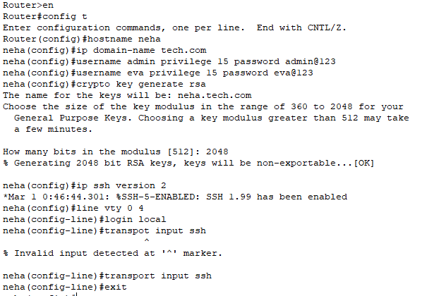

Router5:

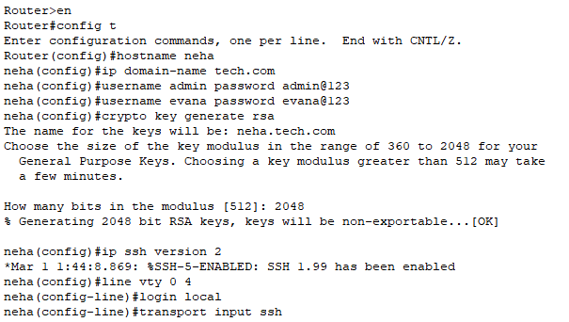

Router | User1 | password1 | User2 | password2
R1 | admin | admin@123 | neha | neha@123
R2 | admin | admin@123 | aaryan | aaryan@123
R3 | admin | admin@123 | sakshi | sakshi@123
R4 | admin | admin@123 | eva | eva@123
R5 | admin | admin@123 | evana | evana@123

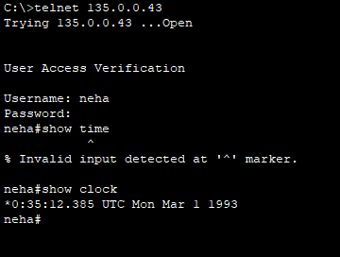

Extended Access Control List:

- allow the ssh for only 135.0.0.9 and 135.0.0.10 for the router 135.0.0.11

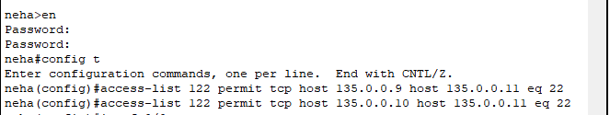
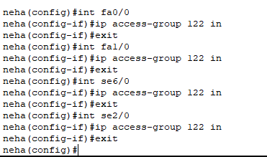

Access the ssh service from the managementPc1 //135.0.0.9

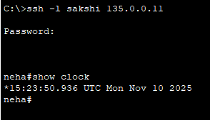

Access the ssh service from the managementPc2 //135.0.0.10

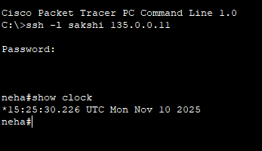

Access the ssh service from the 135.0.0.59

